LeeWayne Barrineau

Chapter 4 practice assignments

4. The recipe and ingredient entities would have a many to many relationships. This would be a many to many relationships because there would be many ingredients linked to a single recipe. While at the same time a single ingredient entity would be link to multiple recipe entities, thus creating the many to many relationships.

5. Below is the dirgram of the realtionship between the recipe and ingredient entities

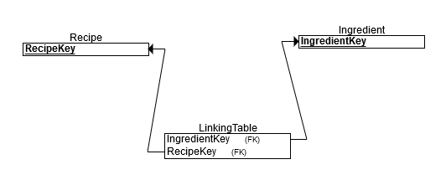

6. In the logical design of the database the relationships between the course and student would be a many to many relationships. Though in the actual design there would need to be a linking table to create a one to many relationships between the course and student. This is a many to many relationships because multiple students can be in multiple course. The relationship between the student entity and the assignment entity would also a many to many relationships, this would also require a linking table to create a one to many relationships. The relationship between these entities is because a single student can be assign to multiple assignments, and a single assignment can be assign to multiple students.

The final relationship between the course and the assignments entities would buck this trend of many to many relationships because one assignment cannot span multiple courses. This meaning that an assignment one course would not be validate in another course.

7. The Entity Relations Diagram below represents the relationships talked about in practice 6

